**1. Reading Assignment: A Short History of Java**

Java was initially developed as part of the "Green Project" at Sun Microsystems. The team included James Gosling, Mike Sheridan, and Patrick Naughton in (1991)

* Officially released in January 1996, Java 1.0 was introduced to the public. It was designed to be a general-purpose language with the slogan "Write Once, Run Anywhere" (WORA), emphasizing its platform independence.
* **Task**: Read about the history and development of Java.
* **Link**: http://sunsite.uakom.sk/sunworldonline/swol-07-1995/swol-07-java.html

**2. Reading Assignment: Java Language Features**

object-oriented programming, simplicity, robustness, security, multithreading, network support, a rich standard library, portability, dynamic capabilities, and modern enhancements

* **Task**: Learn about the main features of Java.
* **Link**: https://javaalmanac.io/features/

**3. Reading Assignment: Which Version of JDK Should I Use?**

To build and run Java applications, a Java Compiler, Java Runtime Libraries, and a Virtual Machine are required that implement the Java Platform, Standard Edition (“Java SE”) specification.

* **Task**: Find out which JDK version is right for you.
* **Link**: https://whichjdk.com/

**4. Reading Assignment: JDK Installation Directory Structure**

Demos and samples that show you how to program for the Java platform are available as a separate downloadDevelopment Files and Directoriesdescribe the most important files and directories required to develop applications for the Java platform. Some of the directories that are not required include Java source code and C header files.Additional Files and Directoriesdescribes the directory structure for Java source code, C header files, and other additional directories and files

* **Task**: Understand the folder structure and files in the JDK installation.
* **Link**: https://docs.oracle.com/javase/8/docs/technotes/tools/windows/jdkfiles.html

**5. Reading Assignment: About Java Technology**

The Java programming language is a high-level language that can be characterized by all of the following buzzwords:Simple, object oriented, Distributed, Multithreaded, Dynamic, Architecture neutral, Portable, High performance, Robust, Secure

* **Task**: Read about the basics of Java technology and its components.
* **Link**: https://docs.oracle.com/javase/tutorial/getStarted/intro/definition.html

**6. Coding Assignments**

1. **Hello World Program**: Write a Java program that prints "Hello World!!" to the console.

class Program {

public static void main(String[] args) {

System.out.println("Hello,World!!");

}

}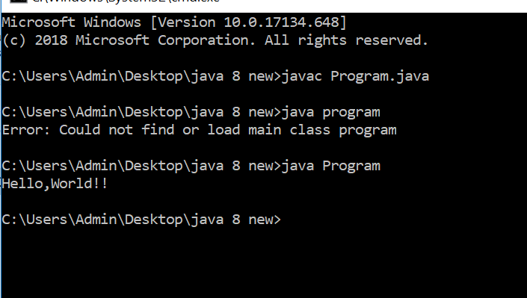

1. **Compile with Verbose Option**: Compile your Java file using the -verbose option with javac. Check the output.

javac -verbose Program.java

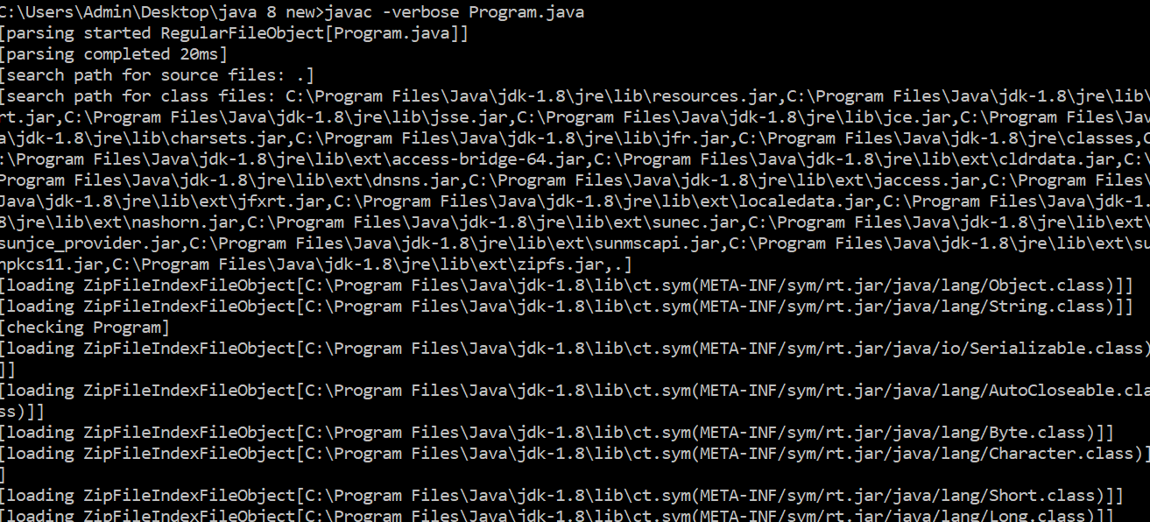

1. **Inspect Bytecode**: Use the javap tool to examine the bytecode of the compiled .class file. Observe the output.

javap -c Program

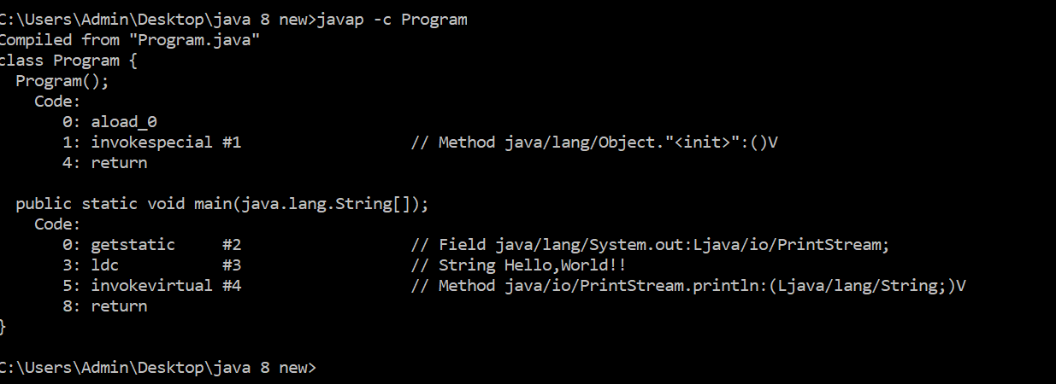

**7. Reading Assignment: The JVM Architecture Explained**



1 ClassLoader Subsystem: Java's dynamic class loading functionality is handled by the ClassLoader subsystem. It loads, links. and initializes the class file when it refers to a class for the first time at runtime, not compile time.BootStrapClassLoader, Extension ClassLoader, Application ClassLoader

2 Runtime Data Area: The Runtime Data Area is divided into five major components:Method Area, Heap area, Stack area, PC registers, native method stacks.

3 Execution Engine: The bytecode, which is assigned to the Runtime Data Area, will be executed by the Execution Engine. The Execution Engine reads the bytecode and executes it piece by piece.

Interpreter, JIT Compiler(Intermediate Code Generator, Code Optimizer ,Target Code Generator, Profiler), Garbage Collector, Native Method Libraries:

* **Task**: Learn about how the Java Virtual Machine (JVM) works.
* **Link**: https://dzone.com/articles/jvm-architecture-explained

**8. Reading Assignment: The Java Language Environment: Contents**

* **Task**: Explore the content and features of the Java language environment.
* **Link**: https://www.oracle.com/java/technologies/language-environment.html

Java language, runtime environment, development tools, class libraries, and platform specifications. It provides a comprehensive framework for developing, running, and managing Java applications across different platforms and environments.